Progressive Education Society's

**Modern College of Engineering, Pune**

**MCA Department**

**A.Y.2023-24**

**(410908) : Data Science Laboratory**

********************************************************************************************* Class: SY-MCA Shift / Div : B (S1) Roll Number : 52119

Name: Harsh Ghodke Assignment No: 4 Date of Implementation: 25/09/2024 *********************************************************************************************

**Q.1) Use the Apriori algorithm on the grocery dataset with minimum support to 0.001 and**

**minimum confidence of 0.8 indicate the top 5 association rules that are generated and**

**highlight the strong ones, sort them by confidence.**

**Ans:-**

# Load necessary libraries

library(arules)

# Load the built-in "Groceries" dataset from the arules package

data("Groceries")

# Apply the Apriori algorithm with specified minimum support and confidence

apriori_rules <- apriori(Groceries, parameter = list(supp = 0.001, conf = 0.8))

# Display the top 5 rules sorted by confidence

sorted_rules <- sort(apriori_rules, by = "confidence", decreasing = TRUE)

top_5_rules <- head(sorted_rules, 5)

# Display the rules with their support, confidence, and lift

inspect(top_5_rules)

**Output:-**

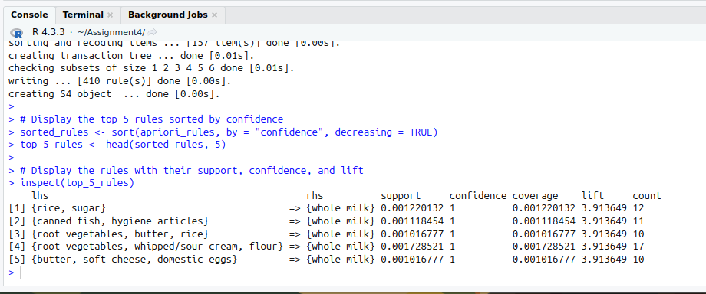

**Q.2) Use the Eclat algorithm on a given Market Basket Dataset and predict the items which are bought frequently.**

**Ans:-**

# Load necessary libraries

library(arules)

# Load the Market Basket dataset

# For demonstration purposes, we'll use the built-in "Groceries" dataset from the arules package

data("Groceries")

# Apply the Eclat algorithm with a minimum support threshold

eclat_result <- eclat(Groceries, parameter = list(supp = 0.001, maxlen = 5))

# Extract the frequent itemsets

frequent_items <- sort(eclat_result, by = "support", decreasing = TRUE)

# Display the top 10 most frequently bought itemsets

inspect(head(frequent_items, 10))

**Output:-**

